

22f-3104

DB_Lab 8



March 28, 2024

fast cfd campus

**Task 1:**

**Create a new table named ‘Product’ with the following attributes:**

**a. Product ID**

**b. Product Name**

**c. Price**

**d. Category**

**e. Stock Quantity (set the default value to 0.)**

**Code:**

CREATE TABLE Product (

ProductID INT NOT NULL,

ProductName VARCHAR(255),

Price INT NOT NULL,

Category VARCHAR(50),

StockQuantity INT DEFAULT 0

);

**Screen Shot:**

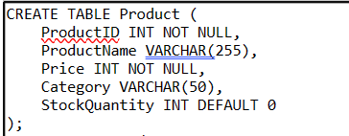

Screen Shot:

**Task 2:**

**Add a primary key constraint to the &quot;Product ID&quot; column in the &quot;Product&quot; table.**

**Code:**

ALTER TABLE Product

ADD CONSTRAINT PK_ProductID PRIMARY KEY (ProductID);  
**Screen Shot:**

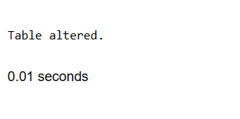

**Task 3:**

**Add a new column ‘Description’ to the ‘Product’ table. (set the default value to ‘No**

**description available.’)**

**Code:**

AlTER TABLE PRODUCT

ADD Description VARCHAR(255) DEFAULT 'NO Description Available'

**Screen Shot:**

**Task 4:**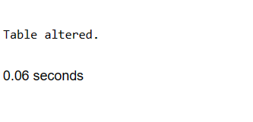

**Apply a unique constraint to the &quot;Product Name&quot; column to ensure product names are**

**unique.**

**Code:**

ALTER TABLE PRODUCT

ADD CONSTRAINT UNI_ProductName UNIQUE (ProductName)

**Screen Shot:**

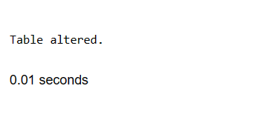

**Task 5:**

**Add a foreign key constraint to the ‘Category’; column, referencing a ‘dept’ table that stores department information.**

**Code:**

ALTER TABLE PRODUCT

MODIFY (CATEGORY Number(2,0));

ALTER TABLE Product

ADD CONSTRAINT FK_Category FOREIGN KEY (Category) REFERENCES dept(DeptNo);

**Screen Shot:**

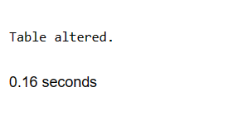

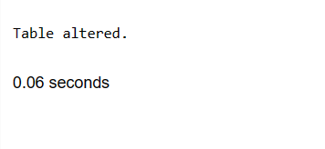

**Task 6:**

**Add a foreign key constraint to the ‘Category’ column, referencing a ‘dept’ table that**

**stores department information.**

**Code:**

CREATE TABLE ORDERS(

OrderID INT PRIMARY KEY,

CustomerID INT NOT NULL,

OrderDate DATE NOT NULL,

TotalAmount INT NOT NULL);

**Screen Shot:**

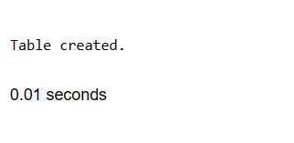

**Task 7:**

**Add a foreign key constraint on the ‘Customer ID’column, referencing a ‘Product’ table.**

**Ensure that updating is not allowed in the parent table, but the parent table can be**

**deleted.**

**Code:**

ALTER TABLE "ORDERS"

ADD CONSTRAINT FK_CustomerID FOREIGN KEY (CustomerID) REFERENCES Product(ProductID)

ON DELETE CASCADE;

**Screen Shot:**

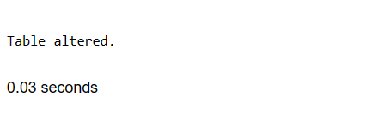

**Task 8:**

**Now delete the ‘Product’ table.**

**Code:**

ALTER TABLE "ORDERS"

DROP CONSTRAINT FK_CustomerID;

DROP TABLE Product;

**Screen Shot:**

**